Vol. 19, Número 1, jan-jun, 2026, pág. 788-808

Dyslexic Word Search:
A Word Hunt app to support dyslexia intervention

Dyslexic Word Search:
Um aplicativo de Caça-Palavras para apoio à intervenção em dislexia

Alan Victor Sarinho de Sousa Lima¹
João Ricardo Lima Abdias de Souza²
Luciana Cidrim³
Francisco Madeiro⁴

ABSTRACT
Dyslexia is a specific learning disability that requires fluency and accuracy in word recognition, directly impacting the academic performance of school-age children. In recent years, the use of digital technologies has established itself as a promising alternative to support external interventions for this population, especially when combined with multisensory approaches and gamification strategies. This article presents Dyslexic Word Search, an application for Android devices that adapts the traditional word hunt game, incorporating visual, auditory, and tactile resources, as well as gamification elements, to enhance user engagement and motivation. The game was developed based on words frequently misspelled by students with dyslexia and structured in progressive levels of difficulty, allowing customization and monitoring of performance in a playful and accessible environment. Thus, Dyslexic Word Search not only adapts a consolidated game, but also reconstructs it pedagogically, articulating educational technology, gamification and multisensory learning to support dyslexia subjects.

Keywords: Application. Dyslexia. Intervention. Technology.

RESUMO
A dislexia é um transtorno específico de aprendizagem que compromete a fluência e a precisão no reconhecimento de palavras, impactando diretamente o desempenho escolar de crianças em idade escolar. Nos últimos anos, o uso
_______________________________________________________

Bacharel em Ciência da Computação pela Universidade Católica de Pernambuco (UNICAP). E-mail: alavictor.sarinho.trabalho@gmail.com. Brasil. ORCID iD: https://orcid.org/0009-0005-6874-537X
2 Bacharel em Ciência da Computação pela Universidade Católica de Pernambuco (UNICAP). E-mail: contact@joasouza.me Brasil. ORCID iD: https://orcid.org/0009-0006-5630-9463
3 Doutora em Ciências da Linguagem pela Universidade Católica de Pernambuco (UNICAP). E-mail: lucianacidrim@gmail.com. Brasil. ORCID iD: https://orcid.org/0000-0000-0000-0000.
⁴ Doutor em Engenharia Elétrica pela Universidade Federal da Paraíba (UFPB). Docente da Universidade Católica de Pernambuco (UICAP). E-mail: francisco.madeiro@unicap.br Brasil. ORCID iD: https://orcid.org/0000-0002-6123-0390.

de tecnologias digitais tem se consolidado como alternativa promissora para apoiar intervenções voltadas a esse público, especialmente quando associadas a abordagens multissensoriais e estratégias de gamificação. Este artigo apresenta o Dyslexic Word Search, um aplicativo para dispositivos Android que adapta o tradicional jogo de caça-palavras, incorporando recursos visuais, auditivos e táteis, bem como elementos de gamificação, a fim de potencializar o engajamento e a motivação dos usuários. O jogo foi desenvolvido com base em palavras frequentemente escritas de modo incorreto por escolares com dislexia e estruturado em níveis progressivos de dificuldade, permitindo personalização e monitoramento do desempenho em um ambiente lúdico e acessível. Assim, o Dyslexic Word Search não apenas adapta um jogo consolidado, mas o reconstrói pedagogicamente, articulando tecnologia educacional, gamificação e aprendizagem multissensorial como suporte às intervenções em dislexia.

Palavras-chave: Aplicativo. Dislexia. Intervenção. Tecnologia.

- INTRODUCTION

Dyslexia is a specific learning disorder characterized by persistent difficulties in the accurate and/or fluent recognition of words, as well as in decoding and spelling abilities, which cannot be explained by factors such as intellectual disability or lack of educational opportunities (American Psychiatric Association, 2014; Reid, 2016; Snowling, 2019). Such difficulties significantly impact academic performance and may affect students’ self-esteem and motivation, making it necessary to implement innovative pedagogical strategies and specialized support resources.
The use of digital technologies in the field of education has proven to be a promising alternative to support the teaching-learning process of students with dyslexia (Fung et al., 2023; Yap, Aruthanan & Chin, 2023). Technological resources enable the development of customized applications that explore different modes of content presentation and allow adaptation to the users’ specific needs (Al-Azawei, Serenelli & Lundqvist, 2017; Helmi, Johar & Subramaniam, 2023). In this context, the use of multisensory strategies — combining visual, auditory, and tactile stimuli — has proven particularly effective, as multisensory learning enhances the consolidation of reading and writing skills (Birsh & Carreker, 2018; Cahyana et al., 2021; Paudel & Acharya, 2024).
Recent research supports the effectiveness of technology as a tool to assist interventions for dyslexia and highlights its growing relevance as an effective assistive resource for students with dyslexia (Shilbi et al., 2024; Paudel & Acharya, 2024). The principles of gamification have been widely incorporated into educational technologies, fostering greater engagement, motivation, and persistence in task performance (Deterding et al., 2011; Behnamghader et al., 2020; Gharaibeh & Dukmak, 2022). Elements such as immediate feedback, symbolic rewards, and level progression contribute to creating more dynamic learning experiences, aligned with the expectations and preferences of schoolaged children (Gee, 2007).
In this context, the present study introduces Dyslexic Word Search, an adaptation of the traditional Word hunt game that integrates multisensory resources and gamification strategies, designed to support pedagogical interventions for students with dyslexia.

- METHODS
  - Reference game

The game that served as inspiration for the development of the application was the traditional ‘Word hunt’. This game consists of a list of target words to be found within a grid of letters, requiring the player to identify all the listed words. The words are formed by selecting letters in sequence, which may be arranged in rows in vertical, horizontal, or diagonal directions. It is possible to select the words both in the forward direction (left to right, top to bottom, descending diagonal) and in reverse (right to left, bottom to top, ascending diagonal).

  - Adaptation to the educational context

In order to adapt the ‘Word hunt’ game to the teaching and learning process of students with dyslexia, the following modifications were implemented:
- Word list: instead of a written list, each item is represented by an image accompanied by a corresponding audio, promoting visual and auditory association;
- Letter grid: the letters were replaced by syllables to strengthen auditory and visual support for word recognition;
- Vocabulary selection: the words used were taken from the Dyslexic Sight Words (DSW) list (Cidrim et al., 2021), which consists of words frequently misspelled by students with dyslexia. This list was developed in Meira’s (2019) doctoral thesis.
This approach aims to strengthen the association between symbols (image and sound) and the written form of words, promoting the development of reading and writing skills in a playful and interactive environment.

  - Application development

The application was developed for the Android operating system, supporting API version 28 (Android 9) and above. This choice is due to the widespread use of this system in Brazil, where approximately 91.7% of mobile devices run Android 9 or higher (GOOGLE, 2025). This criterion ensures greater accessibility for the target audience.
Development was carried out using the Android Studio IDE (GOOGLE, 2025), employing the Kotlin programming language, which is well-established in the Android ecosystem. The graphical interface was built with Jetpack Compose, the main framework for creating modern and declarative interfaces. For audio functionality, the native Text-to-Speech (TTS) library was used, allowing the auditory playback of words presented to the user.

  - Game Model

Each set of words to be found in a game is generated randomly, varying according to the selected difficulty level: easy, medium, or hard. The difficulty level influences the entire game generation process.
The words for each game are selected from a sublist of the ‘DSW’, excluding compound words. This list is organized in ascending order according to the number of letters, so that the initial words have lower complexity, while the later words are more challenging. The number of words varies according to the difficulty level:
- Easy: 4 words
- Medium: 5 words
- Hard: 6 words
For each game, an empty grid is generated, with the size varying according to the difficulty level:
- Easy: 5 rows × 4 columns
- Medium: 6 rows × 4 columns
- Hard: 7 rows × 4 columns

From the perspective of the app designer in order to fill the grides of syllables, the words to be found by player are broken down into syllables. For each word, a starting position and an insertion direction (horizontal, vertical, or diagonal) are randomly chosen. If it is not possible to place the word in the selected position, then the process is repeated until all words are properly inserted. The remaining spaces in the grid are filled with random syllables.
At the end of the game, the application records the player’s performance metrics, including:
- total time (in seconds) to complete the game;
- number of errors made;
- time (in seconds) to complete each word.

3. RESULTS
3.1 Main screen

The mainscreen of ‘Dyslexic Word Search’ (DWS) was designed with a user-centered approach, emphasizing usability and accessibility. Upon startup, the system presents the user with an interface composed of the abbreviated application title (DWS), a graphic icon alluding to a video game, and three navigation buttons that structure its main functionalities, as observed in Figure 1.
- Play (corresponding to the Portuguese word ‘jogar’): starts a new game;
- History (corresponding to the Portuguese word ‘histórico’): displays the record of previously played games;
- Information (corresponding to the Portuguese word ‘informações’): provides additional details about the application.
The button corresponding to the “Play” functionality is displayed in green, distinguishing it from the others. This choice aims to highlight the system’s primary action, facilitating quick identification of its main functionality and aligning with interaction design guidelines related to visibility.
For the interface development, criteria of simplicity and low visual clutter were adopted in order to ensure a more intuitive, accessible, and effective user experience (Figure 1).

3.2 Difficulty level selection screen

When the “Play” button is pressed, the user is directed to the difficulty selection (corresponding in Portuguese to ‘seleção de dificuldade’) screen, shown in Figure 2. Three difficulty levels are available: easy (‘fácil’ in Portuguese), medium (‘médio’ in Portuguese), and hard (‘difícil’ in Portuguese). Each difficulty level was designed to provide a progressive experience. This perception is achieved through variations in:

- Set of words: adjusted according to the level, with greater lexical complexity at higher difficulties;
- Word placement directions: progressively expanded, covering horizontal, vertical, and diagonal combinations;
- Grid size: increased as the difficulty level rises;
- Number of words per game: incremented to intensify the cognitive challenge.

The combination of these elements establishes a progression that is essential to sustaining user motivation. As learners with dyslexia move from easier to more complex levels, they are gradually exposed to increasingly challenging tasks, which stimulates the development of linguistic skills and strengthens the perception of gradual mastery of the activity. This mechanism aligns with gamification principles that emphasize the balance between challenge and competence as a key motivational factor for continued engagement.

Figure 1. Application home screen | Figure 2. Difficulty level selection screen

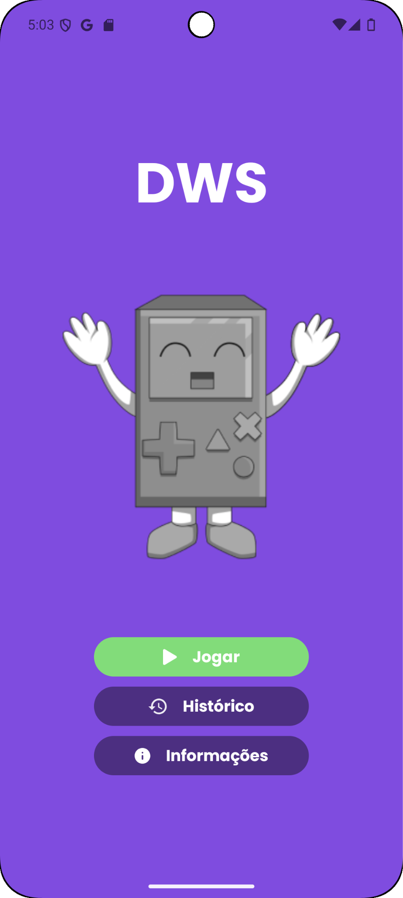 | 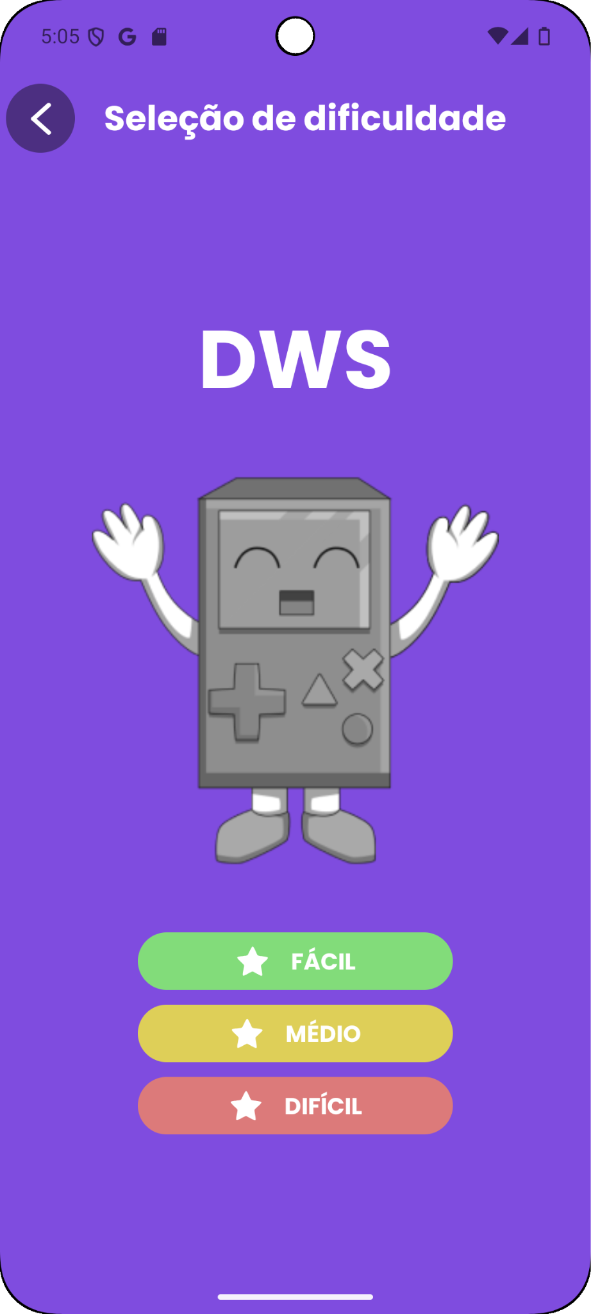
Fonte: Elaborated by the authors. | Fonte: Elaborated by the authors.

3.3 Game screen

After selecting the difficulty level, the user is directed to the game screen, shown in Figure 3. This interface is organized into different functional areas, each with specific objectives related to usability, accessibility, and monitoring the user’s performance:
- Back button: when pressed, a confirmation window is displayed (Figure 4), asking the user whether they intend to exit the game;
- Central text: indicates the previously selected difficulty, reinforcing the context of the ongoing game;
- Help button: provides access to a brief tutorial with instructions on how the game works, supporting user understanding and facilitating interaction;
- Progress stars: graphically represent the player’s performance, showing the number of words already identified relative to the total. With each correct answer, the corresponding star changes color from white to yellow, serving as an immediate feedback mechanism;
- Timer: displays the elapsed time since the start of the game, allowing the user to monitor their performance;
- Syllable grid: serves as the central interaction space, where the user must locate words from the arranged syllables;
- Bottom bar: displays images corresponding to the words to be found.

When an image is clicked, the system plays the word’s audio, supporting the association between visual and auditory stimuli — a feature particularly relevant for learners with dyslexia.

Figura 3. Game Screen | Figura 4. Exit Confirmation Screen
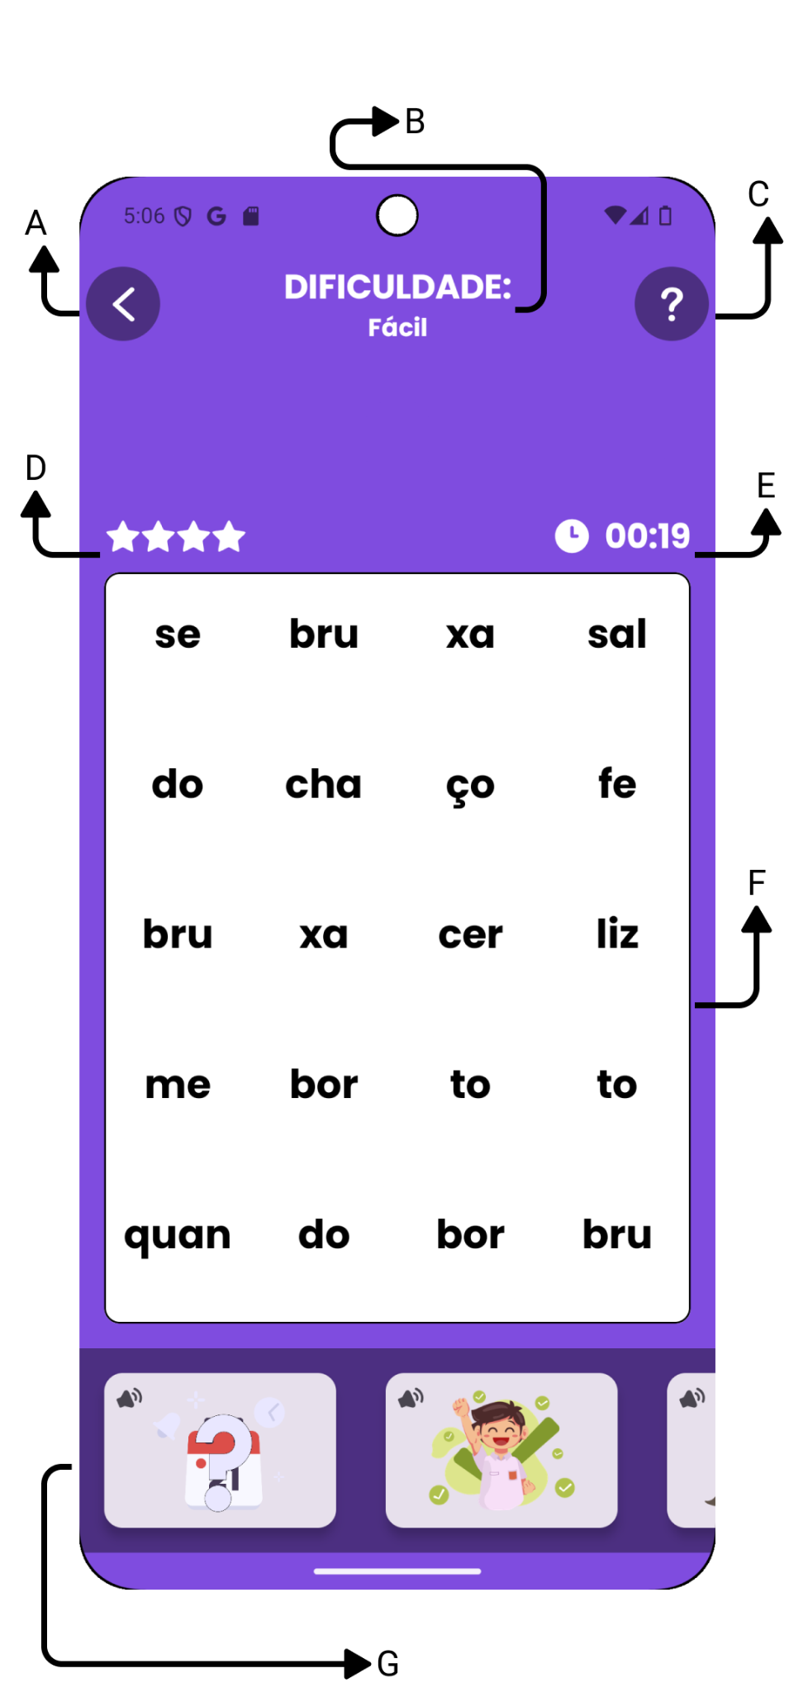 | 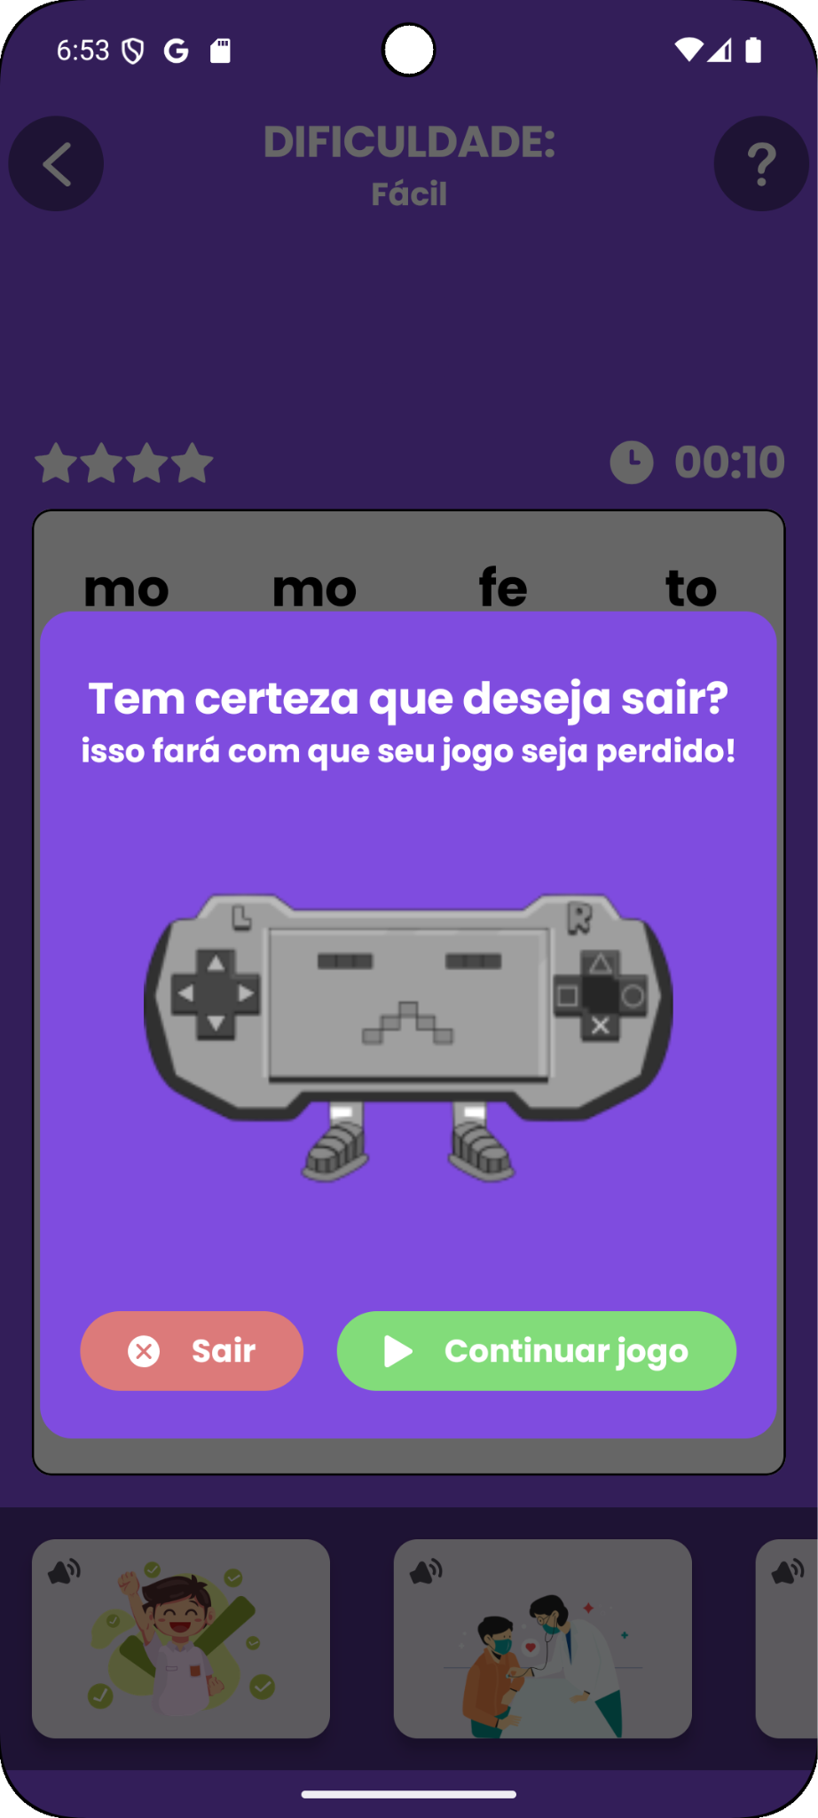
Fonte: Elaborated by the authors. | Fonte: Elaborated by the authors.

3.4 Game dynamics
The gameplay is structured into levels that integrate multisensory association (visual and auditory) and tactile interaction. Initially, the user observes the images displayed on the bottom bar of the screen and, when necessary, can activate the associated audio by clicking on the corresponding image.
Subsequently, the user must identify, within the syllable grid, the sequence that forms the word related to the image and audio. Selection is performed by pressing and dragging the finger, connecting the syllables in sequential order. During this interaction, the word being formed is displayed in real time on the display located below the central text, providing immediate feedback on the user’s action.
Upon completing the selection movement, two response outcomes may occur:
- Correct selection: the word displayed on the screen disappears, the system emits a sound signal (bell), and a new yellow star is added, representing progress in the game (Figure 5);
- Incorrect selection: the device vibrates, and the display shows the message “Invalid word” (‘palavra inválida’ in Portuguese) highlighted in red (Figure 6).
This interaction dynamic combines positive and negative feedback, which helps sustain user motivation. Moreover, the use of multiple stimuli (visual, auditory, and tactile) contributes to enhancing accessibility and addressing the needs of the target audience.

Figura 5. Word Correctness Screen | Figura 6. Invalid Word Screen
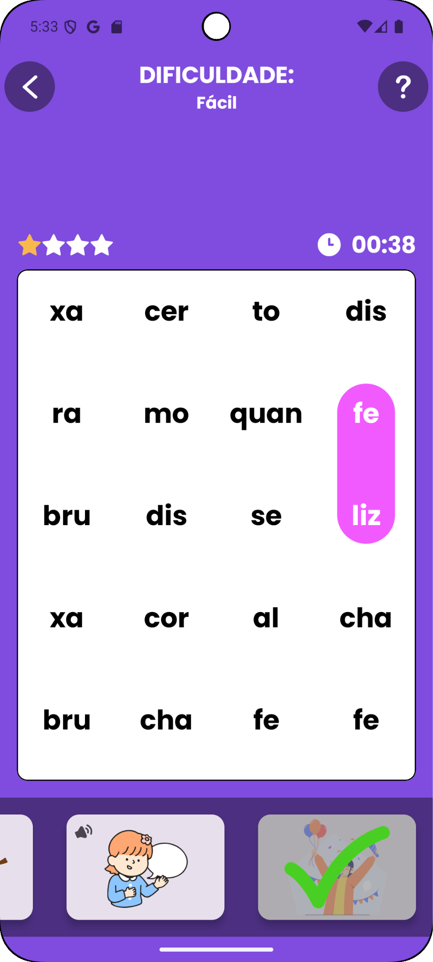 | 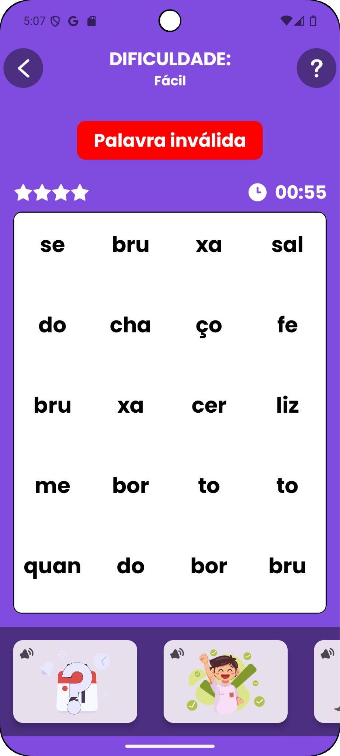
Fonte: Elaborated by the authors. | Fonte: Elaborated by the authors.
3.5 Game completion screen

At the end of the game, when all words are correctly identified, the user is redirected to the game completion screen, shown in Figure 7. A congratulatory message is displayed, followed by a performance score containing the following information:

- Total execution time: the duration required to complete the game;
- Penalized time: the value obtained by adding 10 seconds for each error to the actual time;
- Individual ranking: displays the player’s top five scores for the corresponding difficulty level.
The use of time as a scoring criterion aims to encourage learners with dyslexia to develop greater familiarity with the syllabic composition of words, promoting repeated practice as they attempt to surpass their previous performance. This process supports the consolidation of knowledge of words and syllables. Moreover, the gradual progression of difficulty levels allows for adaptive learning: initially presenting simpler challenges and, subsequently, words of greater complexity, thereby facilitating a progressive learning process.

3.6 Game history screen

The game history screen, illustrated in Figure 8, displays a complete record of the user’s interactions with the application. Each game is represented by an informational panel containing the following data: completion date, difficulty level, total execution time, and number of errors made. Additionally, by pressing the expansion button (downward arrow icon), the panel is expanded to reveal the time required to complete each word in the respective game.
This functionality plays a central role for both the user and the professional responsible for intervention. From the user’s perspective, it allows for individual progress tracking, reinforcing the perception of improvement over time. For the professional, the history provides analytical data on performance, enabling the identification of difficulty patterns, such as words that required more time to solve, and guiding more effective intervention strategies. In this way, the game history serves as a tool to monitor the user’s progress.

Figura 7. Game Completion Screen | Figura 8. Game History Screen
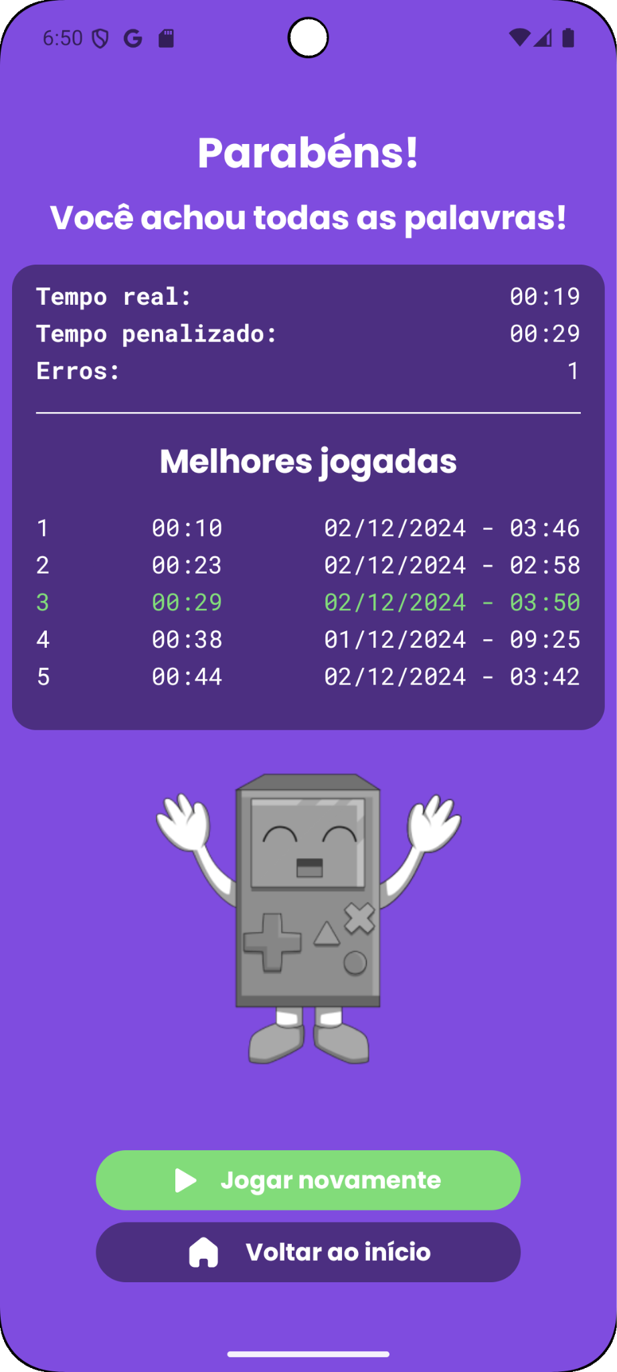 | 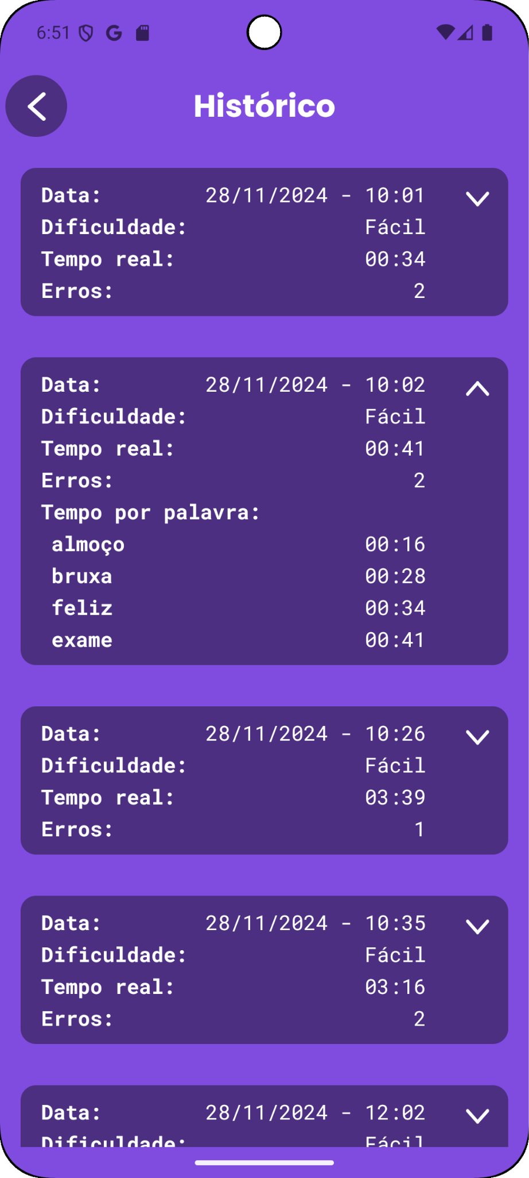
Fonte: Elaborated by the authors. | Fonte: Elaborated by the authors.

4. DISCUSSION OF RELATED WORKS

Cidrim and Madeiro (2017) conducted an integrative review of national and international literature with the aim of investigating spelling difficulties presented by individuals with dyslexia, as well as identifying the main intervention approaches described for this population. Recent studies have addressed relevant issues within the scope of dyslexia.
Nevill and Forsey (2023), for example, presented a systematic literature review examining the social impact of schooling on students with dyslexia. The authors discuss the school experiences of students with dyslexia, parents’ experiences, and issues related to schools’ responses to these students.
Romero et al. (2023) introduced the Berni software, aimed at early intervention for children with dyslexia, focusing on phonological awareness, verbal memory, alphabetic awareness, receptive language, and writing awareness. The study involved preschool children from the Basque Country (Spain) who showed risk indicators for dyslexia.
The systematic literature review by Yap, Aruthanan and Chin (2023) highlights applications of artificial intelligence (AI) in the context of dyslexia, including early detection and diagnosis, personalized learning, and interventions. The study also discusses key issues regarding AI in dyslexia, such as balancing AI assistance with human experience and ensuring transparency in AI decision-making.
Fung et al. (2023) addressed a particular challenge for students with dyslexia in Hong Kong: learning Chinese characters. The authors presented a mobile application aimed at this learning process. The study found that the application could reduce the time required for students with dyslexia to write specific characters.
AlphAR is a web-based augmented reality (AR) system presented by Shilbi et al. (2024) to address symbol recognition difficulties in children with dyslexia. The system, which uses marker-based AR and audio cues, increases engagement. According to the authors, combining 3D models and audio signals in AlphAR enhances the learning experience by providing a multisensory approach to symbol recognition.
Perera and Sumanathilaka (2025) examined the use of natural language processing (NLP) approaches in the development of tools to support adult Sinhala speakers with dyslexia. The study notes a lack of solutions focused on dyslexic adults.
Another study involving the use of technology in dyslexia was conducted by Helmi, Johar, and Subamaniam (2023), who developed a mobile application utilizing the Google Speech Recognizer API, allowing students with learning difficulties, such as dyslexia, to practice reading and pronunciation skills.
The following section presents studies by Brazilian researchers involving the use of technology as support tools for dyslexia intervention.
Duarte Filho, Madeiro and Cidrim (2024) introduced ‘Meu Amigo Diggo’, an Android-based application designed to support reading and spelling intervention in students with learning disorders, particularly dyslexia. The application offers activities such as ‘Palavras com o Diggo’ and ‘Labirinto de Letras’, as well as a reading activity associated with the Cloze technique and Aesop’s fables. The use of the mascot Diggo aims to facilitate user engagement with the application. For reading activities, Aesop’s fables, in addition to being short stories, convey important moral lessons. The application incorporates gamified challenges that stimulate reading and spelling skills through a set of activities designed within an intuitive and engaging interface.
Cartas na Manga is an application developed using the Integrated Development Environment (IDE) Android Studio and VSCode (Software Development Kit – SDK) version 3.0.1. According to Barros et al. (2023), the application can be used by education professionals, such as speech therapists, pedagogues, and educational psychologists, working with dyslexia intervention in young adults. ‘Cartas na Manga’ aims to support the learning of orthographic spelling of words containing digraphs for young adults with dyslexia. The use of cards with images related to the digraph strokes is intended to promote memorization of correct spelling through associative visual elements (image/letter).
‘Descomplicando’ was developed for multiple platforms (Android and iOS), using Visual Studio Code and Android Studio Dolphin, with the Dart language and the Flutter framework. Designed for smartphones, it features a responsive interface that adapts layout components to different screen sizes. Sound effects were implemented through the Flutter package audioplayers. ‘Descomplicando’ was developed to support intervention in students with learning disorders, focusing on spelling, particularly words with complex syllabic structures (Rocha et al., 2023).
‘Ortografando’, developed by Ribeiro et al. (2021), was designed to support interventions in spelling difficulties, particularly for students with dyslexia. The tool can be used by speech therapists, pedagogues, and other education professionals. It is also accessible for independent use by students through an intuitive and easy-to-use interface. One of the application’s key features is a recording function, allowing students to note their own discoveries about correct spelling, promoting active learning and consolidation of orthographic lexical memory.
‘Desembaralhando’, developed by Cidrim, Braga and Madeiro (2018), aims to assist speech therapy interventions focused on letter reversals in students with dyslexia. The app’s activities were designed to stimulate phonological awareness skills through image-audio associations, allowing users to hear the names of figures or record their own voice. Additionally, the app features an innovative resource: rotation of commonly confused letters (e.g., b/d and a/e), which helps improve visual tracing perception and reduces reversal errors.
Lucena, Cidrim and Madeiro (2017) developed an application inspired by traditional crossword puzzles to stimulate the memorization of word spellings alongside the development of phonological awareness. Silva Júnior, Cidrim and Madeiro (2019) presented a digital version of the Rapid Automatized Naming (RAN) test, using mobile device features such as the microphone and internet access to automate the test and measure variables like time, number of correct answers, and errors through voice recognition.

5. FINAL CONSIDERATIONS

Dyslexic Word Search is an adaptation of the traditional ‘Word hunt’ game, designed to support interventions for students with dyslexia. Unlike the classic version, the application was developed with a user-centered design, emphasizing accessibility and the use of multimodal stimuli.
The integration of educational technology, gamification elements, and multimodal resources (visual, auditory, and tactile) aims to provide a more inclusive, motivating, and effective learning experience. Gamification, through mechanisms such as difficulty progression, immediate feedback, and symbolic rewards, enhances user motivation and engagement. Therefore, Dyslexic Word Search not only adapts a well-established game but also reconstructs it from a pedagogical perspective, combining gamification principles and multisensory learning as a support tool for teaching students with dyslexia.

REFERENCES

Al-Azawei, A., Serenelli, F., & Lundqvist, K. (2016). Universal design for learning (UDL): A content analysis of peer-reviewed journal papers from 2012 to 2015. Journal of the Scholarship of Teaching and Learning, 16(3), 39–56. https://doi.org/10.14434/josotl.v16i3.19295

American Psychiatric Association. (2014). Manual diagnóstico e estatístico de transtornos mentais: DSM-5 (5ª ed.). Artmed.

Barros, R. R. da S., Cidrim, L., Roazzi, M., & Madeiro, F. (2023). Cartas na Manga: Um aplicativo para apoio à intervenção da dislexia em jovens adultos. Revista Amazônica, 16(2), 770–793. https://share.google/OvYlJW3wpypO2eu4o

Behnamghader, M., Khaleghi, A., Izadpanah, P., & Rahmani, F. (2020). Using gamification based on mobile platform in therapeutic interventions for children with dyslexia. In M. E. Auer & T. Tsiatsos (Eds.). Internet of things, infrastructures and mobile applications, pp. 814–824. Springer. https://doi.org/10.1007/978-3-030-49932-7_76

Birsh, J. R., & Carreker, S. (2018). Multisensory teaching of basic language skills (4th ed.). Paul H. Brookes Publishing.

Cahyana, C., Hidayati, H., Sanjaya, M., Pangestu, A., Sundawa, A., & Aritakalam, A. (2021). Leady: A multisensory approach in mobile application for dyslexic children. International Journal of Communication and Information, 15(1), 31–39. https://doi.org/10.21512/commit.v15i1.6661

Cidrim, L., & Madeiro, F. (2017). Studies on spelling in the context of dyslexia: A literature review. Revista CEFAC, 19 (6), 842–854. https://doi.org/10.1590/1982-0216201719610317

Cidrim, L., Braga, P., & Madeiro, F. (2018). Desembaralhando: A mobile application for intervention in the problem of dyslexic children mirror writing. Revista CEFAC, 20(1), 13–20. https://doi.org/10.1590/1982-021620182015217

Cidrim, L., Azevedo, N. P. G., & Madeiro, F. (2021). Elaboração de uma lista de palavras no âmbito da ortografia para escolares com dislexia: ’Dyslexic sight words’. Revista Psicopedagogia, 38(115), 5–17. https://doi.org/10.51207/2179-4057.20210001

Deterding, S., Dixon, D., Khaled, R., & Nacke, L. (2011). From game design elements to gamefulness: Defining “gamification”. In Proceedings of the 15th International Academic MindTrek Conference: Envisioning Future Media Environments, pp. 9–15. ACM. https://doi.org/10.1145/2181037.2181040

Duarte Filho, C., Madeiro, F., & Cidrim, L. (2024). Meu Amigo Diggo: A tool to stimulate reading and spelling skills in students with learning disabilities. Revista CEFAC, 26(6), e3024. https://doi.org/10.1590/1982-0216/20242613024

Fung, K., Perrault, S., Lee, K., Fung, C., & Song, S. (2023). Can students with dyslexia learn independently? A seven-week study of Chinese character learning in an informal learning environment. IEEE Transactions on Learning Technologies,16(5), 619-632. http://doi.org.br/10.1109/TLT.2022.3229016.

Gharaibeh, M., & Dukmak, S. (2022). Effect of computer-based multisensory program on English reading skills of students with dyslexia and reading difficulties. Applied Neuropsychology Child, 11(3), 504–517. https://doi.org/10.1080/21622965.2021.1898395

Google. (2025). Android Studio: The official IDE for Android. https://developer.android.com/studio

Helmi, N. F., Johar, M. G. M., & Subramaniam, R. K. (2023). Speech recognition Android app with dyslexia for children using AI. 1st International Conference on Advanced Innovations in Smart Cities (ICAISC). Saudi Arabia, pp. 1–5. https://doi: 10.1109/ICAISC56366.2023.10085189.

Lucena, G., Cidrim, L., & Madeiro, F. (2017). Um aplicativo para estimulação da memória visual em crianças disléxicas por meio do jogo de palavras cruzadas. Anais do XXVIII Simpósio Brasileiro de Informática na Educação (SBIE), VI Congresso Brasileiro de Informática na Educação e XXVIII Simpósio Brasileiro de Informática na Educação, 685–694. Recife.

Meira, L. C. C. (2019). “Dyslexic Sight Words” (DSW) e intervenção fonoaudiológica em escolares com dislexia (Tese de doutorado, Universidade Católica de Pernambuco). UNICAP.

Nevill, R., & Forsey, M. (2023). The social impact of schooling on students with dyslexia: A systematic review of the qualitative research on the primary and secondary education of dyslexic students. Educational Research Review, 38,100507. https://doi.org/10.1016/j.edurev.2022.100507

Paudel, U., & Acharya, D. (2024). Assistive technologies for dyslexia: A systematic review. Education and Information Technologies, 29(1), 511–534. https://doi.org/:10.48550/arXiv.2412.13241

Perera, P., & Sumanathilaka, D. (2025). Recent trends and challenges in assistive applications for Sinhala-speaking adults with dyslexia: A decade in review. 2025 5th International Conference on Advanced Research in Computing (ICARC), 1–6.
https://doi.org/10.1109/ICARC64760.2025.10963092

Reid, G. (2016). Dyslexia: A practitioner's handbook (5th ed.). Malden, MA: John Wiley & Sons Ltd.

Ribeiro, T., Cidrim, L., Capellini, S., & Madeiro, F. (2021). Ortografando: Um aplicativo para trabalhar a escrita ortográfica em escolares com dislexia. In: Caiado, Roberta; Leffa, Vilson. (Org.). Linguagem: Tecnologia e Ensino. 1ed. Campinas: Pontes Editora, v. 1, p. 180–197.

Rocha, A., Cidrim, L., Soares, L., Roazzi, M., & Madeiro, F. (2023). Descomplicando: Uma aplicação para apoio à intervenção em escolares com transtornos de aprendizagem no âmbito da ortografia. Revista Amazônica,16,1093–1117. https://dialnet.unirioja.es/servlet/articulo?codigo=9951053

Romero, A., Garay, U., Tejada, E., & López de la Serna, A. (2023). Efficacy of Berni: A software for preschoolers at risk of dyslexia. IJCCI, 38, 100411. https://doi.org/10.1016/j.ijcci.2021.100411

Shilbi, S., Chhirolya, V., Basha, N., & Surendiran, B. (2024). Interactive learning with AlphAR: A symbol-recognition aid for dyslexic children through augmented reality. 2024 International Conference on Signal Processing, Computation, Electronics, Power and Telecommunication (IConSCEPT), Karaikal, pp.1–6. http://doi: 10.1109/IConSCEPT61884.2024.10627885

Silva Júnior, D., Cidrim, L., & Madeiro, F. (2019). Digital version of the Rapid Automatized Naming (RAN): a contribution to early detection of reading problems in children. Revista CEFAC, 21(2), e14218. https://doi.org/10.1590/1982-02162019214218

Snowling, M. J. (2019). Dyslexia: A very short introduction (2nd ed.). Oxford University Press.

Yap, J. R., Aruthanan, T., & Chin, M. (2023). Artificial intelligence in dyslexia research and education: A scoping review. IEEE, 13, 7123–7134. https://doi.org/10.1109/access.2025.3526189

Submetido em: 15/12/2025
Aprovado em: 28/12/2025
Publicado em: 01/01/2026

Autores
Alan Victor Sarinho de Sousa Lim
Bacharel em Ciência da Computação pela Universidade Católica de Pernambuco (UNICAP). E-mail: alavictor.sarinho.trabalho@gmail.com. Brasil. ORCID iD: https://orcid.org/0009-0005-6874-537X

João Ricardo Lima Abdias de Souza
Bacharel em Ciência da Computação pela Universidade Católica de Pernambuco (UNICAP). E-mail: contact@joasouza.me Brasil. ORCID iD: https://orcid.org/0009-0006-5630-9463

Luciana Cidrim
Doutora em Ciências da Linguagem pela Universidade Católica de Pernambuco (UNICAP). E-mail: lucianacidrim@gmail.com. Brasil. ORCID iD: https://orcid.org/0000-0000-0000-0000.

Francisco Madeiro
Doutor em Engenharia Elétrica pela Universidade Federal da Paraíba (UFPB). Docente da Universidade Católica de Pernambuco (UICAP). E-mail: francisco.madeiro@unicap.br Brasil. ORCID iD: https://orcid.org/0000-0002-6123-0390

